ASSIGNMENT 2
QUESTIONS
CO2: Analyze public-key cryptosystem strategies using RSAandkeyexchange for encryption algorithms to strengthen information security.
CO2 Coverage: Symmetric key cryptosystems; Data EncryptionStandard (DES); Triple DES (3DES); Blowfish; RC5; block ciphers; stream ciphers; block cipher modes of operation; public-keycryptosystems; RSA algorithm; key distribution and management; Diffie–Hellman key exchange; elliptic curve cryptography (ECC); introductionto quantum cryptography; number-theory foundations; RSAattacks andpadding; digital signatures; hybrid encryption.
Assignment Title: Evaluate, Design and Defend a Secure Public-Keyand Hybrid Cryptographic Strategy for a Multi-Site Healthcare Network(Total Marks: 50)
Scenario — Secure Healthcare Data Exchange
A healthcare network connects one central hospital with remote clinicsthat exchange patient records, prescriptions, diagnostic reports andbillingdata over public networks. The network contains low-resource devices, high-volume file transfers and multiple security requirements. Thesecurity team must select appropriate symmetric and public-keytechniques, establish keys securely, authenticate exchanges and preparefor long-term cryptographic migration.
The system must:
● Protect stored and transmitted clinical records with confidentiality. ● Establish session keys over an observable public network. ● Provide authentication and integrity for security-sensitiveexchanges.
● Support large files without performing expensive public-keyencryption on every data block.
● Remain practical for constrained clinics while allowing securemigration as threats and technology change.
Design Challenge
During peak operation the network expands to many remote sites. Anattacker can observe traffic, attempt a man-in-the-middle attackduringunauthenticated key exchange, exploit weak RSA parameters, andanalyse repeated ciphertext patterns. Management also requires amigration plan for future quantum threats. Re-evaluate the original designusing your mathematical and experimental evidence.
Q1 – Symmetric Cryptosystem Selection and Modes of Operation(7Marks)
Problem Context – Protecting Clinical Records
The network must compare classical symmetric choices before usingpublic-key techniques. Evaluate DES, 3DES, Blowfish and RC5, together with the distinction between block and stream ciphers and the principal block-cipher modes.
Your Challenge
● Explain the structure, block size, key characteristics androundoperation of DES, 3DES, Blowfish and RC5.
● Implement or simulate at least three of these algorithms on student- created test data and verify encryption/decryption.
● Explain the difference between block and streamciphers andidentify an appropriate use for each.
● Explain ECB, CBC, CFB, OFB and CTR, including IV/noncerequirements, pattern leakage, error propagation and parallelism. ● Demonstrate why ECB can reveal repeated plaintext patterns andwhy IV/nonce reuse is dangerous.
● Compare operation count and execution time for increasingmessage sizes.
Evaluation
Rank DES, 3DES, Blowfish and RC5 for the scenario, identifylegacylimitations, and recommend where a block or streamconstructionwouldbe appropriate. Do not treat a larger key space alone as proof of security.
Evidence Expected: Algorithm comparison, mode comparison, test results, pattern/IV demonstration and a justified recommendation.

ANSWER:
Q1. Symmetric Cryptosystem Selection and Modes of Operation (7 Marks)
1. Introduction:
Symmetric encryption is a method of protecting data using the same secret key for encryption and decryption. It is commonly used because it is fast and suitable for encrypting large files.
In healthcare systems, it protects patient records, medical reports and billing information during storage and transmission.
2. Comparison of Symmetric Algorithms:
DES (Data Encryption Standard): DES encrypts data in 64-bit blocks using a 56-bit key. It uses 16 encryption rounds. It is now considered insecure because its key size is too small.
3DES (Triple DES): 3DES applies DES three times using multiple keys. It provides better security than DES but is slower and has a 64-bit block size.
Blowfish: Blowfish is a block cipher that uses a 64-bit block and a variable key size of 32–448 bits. It uses 16 rounds and provides fast encryption.
RC5: RC5 is a flexible block cipher that supports different block sizes, key lengths and numbers of rounds. It uses XOR, addition and rotation operations.

Algorithm | Block Size | Key Size | Rounds
DES | 64 bits | 56 bits | 16
3DES | 64 bits | 112/168 bits | 48 DES rounds
Blowfish | 64 bits | 32–448 bits | 16
RC5 | Variable | Variable | Variable
3. Block Cipher and Stream Cipher:
- Block Cipher: Encrypts data in fixed-size blocks. Example: DES, AES and Blowfish.
- Stream Cipher: Encrypts data continuously, one bit or byte at a time. Example: ChaCha20.
Block ciphers are suitable for file encryption, whereas stream ciphers are useful for continuous data communication.
4. Modes of Operation:
Modes of operation explain how a block cipher encrypts large amounts of data.
1. ECB (Electronic Codebook): Encrypts each block separately. Identical plaintext blocks produce identical ciphertext blocks, revealing data patterns.
2. CBC (Cipher Block Chaining): Combines each plaintext block with the previous ciphertext block. It uses an Initialization Vector (IV) to protect the first block.
3. CFB (Cipher Feedback): Converts a block cipher into a stream-like method and encrypts smaller data units.
4. OFB (Output Feedback): Generates a continuous keystream for encryption. Transmission errors do not spread to later plaintext blocks.
5. CTR (Counter Mode): Uses a counter to generate a keystream. It supports fast and parallel encryption.

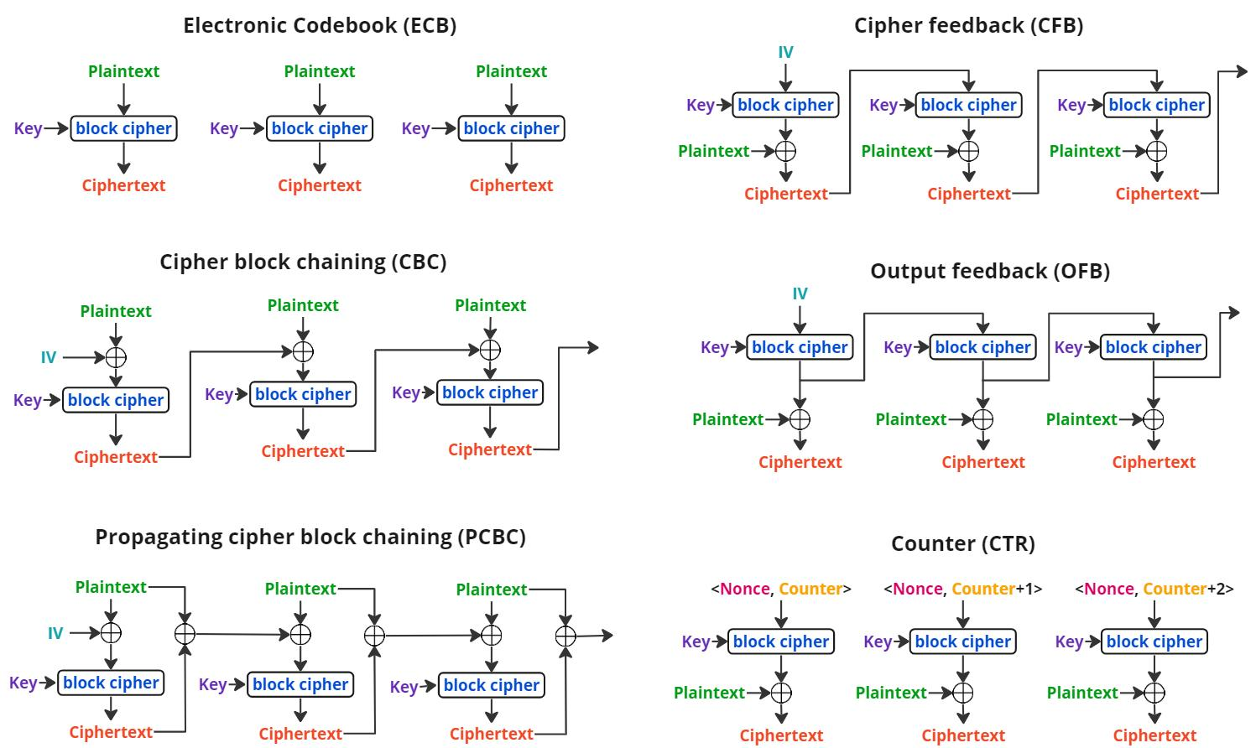
5. Comparison of Modes:
Mode | Main Feature | Limitation
ECB | Simple and parallel | Reveals patterns
CBC | Hides repeated patterns | Sequential encryption
CFB | Stream-like encryption | Error propagation
OFB | Errors do not spread | IV reuse is dangerous
CTR | Fast and parallel | Nonce reuse is dangerous
6. Why ECB and IV Reuse Are Dangerous:
ECB produces the same ciphertext for identical plaintext blocks. Therefore, attackers can identify repeated patterns.
For example:
- Plaintext: AAAAA BBBBB AAAAA
- ECB ciphertext: XXXXXX YYYYY XXXXXX
The repeated blocks remain visible.
In CTR mode, reusing the same key and nonce generates the same keystream. This can expose information about the original messages.
Therefore, unique IVs or nonces must be used as required by the encryption mode.
7. Performance Comparison:
For a 64-bit block cipher, the number of blocks increases with message size.
Message Size | Number of Blocks
64 bytes | 8
128 bytes | 16
256 bytes | 32
512 bytes | 64
3DES performs three DES operations per block, so it generally requires more processing than DES.
8. Recommendation:
For the healthcare network:
- DES and 3DES should be avoided because they are outdated.
- Blowfish and RC5 can be studied but are not preferred for new systems.
- AES-256-GCM is recommended for secure healthcare file encryption.
- ChaCha20-Poly1305 is another suitable option for efficient software-based encryption.
9. Conclusion:
Symmetric encryption provides fast and efficient protection for healthcare data. DES, 3DES, Blowfish and RC5 have different security and performance characteristics. Among the different modes, ECB is unsafe for sensitive data because it reveals repeated patterns. Therefore, modern authenticated encryption such as AES-GCM is recommended for secure healthcare communication.

Q2 – Number-Theory Engine and Prime Selection for RSA(6Marks)
Problem Context – RSA Key Generation RSA depends on modular arithmetic, modular inverses, modular exponentiation and the generation of suitable primes.
Your Challenge
● Implement GCD, Extended Euclidean Algorithm, modular inverseand fast modular exponentiation.
● Compare trial-search inverse with Extended Euclid andnaiverepeated multiplication with square-and-multiply.
● Explain Euler’s totient function and the condition gcd(e, φ(n)) =1. ● Compare trial division, Fermat and Miller–Rabin on safetoycandidates, including Carmichael numbers such as 561, 1105and1729.
● Record modular multiplications, division/loop steps andfalseacceptance results.
● Explain how prime density affects the number of candidates tested. ● Re-evaluate the methods when the RSA modulus grows fromclassroom-sized values toward 1024-, 2048- and 3072-bit engineering requirements.
Evidence Expected: Mathematical derivations, pseudocode, designedtest cases, operation counts, primality-test evidence and engineeringdecision.

ANSWER:
Q2 – Number-Theory Engine and Prime Selection for RSA (6 Marks)
1. Introduction:
RSA depends on number theory and modular arithmetic. Important operations include finding the GCD, modular inverse, modular exponentiation and selecting suitable prime numbers.
These operations help generate secure RSA public and private keys.
2. Important Number-Theory Concepts:
a) Greatest Common Divisor (GCD):
GCD is the largest number that divides two integers without leaving a remainder.
Example:
GCD(48,18) = 6
b) Extended Euclidean Algorithm:
The Extended Euclidean Algorithm finds the GCD and also calculates integers (x) and (y) such that:
ax+by = GCD(a,b)
c) Modular Inverse:
The modular inverse of (a) modulo (m) is a number (x) satisfying:
$$\left(a×x\right) \operatorname{mod}{m} =1$$
Example:
$$3^{-1} \operatorname{mod}{11} =4$$
Because:
$$\left(3×4\right) \operatorname{mod}{11} =1$$
d) Modular Exponentiation:
Modular exponentiation calculates large powers using a modulus.
$$a^{b} \operatorname{mod}{m}$$
The square-and-multiply method performs this calculation efficiently by repeatedly squaring and multiplying only when required.
3. Euler's Totient Function:
Euler's Totient Function, represented by $ϕ\left(n\right),$counts the positive integers less than or equal to n that are relatively prime to n.
For RSA, two prime numbers p and q are selected.
$$n=p×q$$
$$ϕ\left(n\right)=\left(p-1\right)\left(q-1\right)$$
The public exponent e must satisfy:
$$GCD\left(e,ϕ\left(n\right)\right)=1$$
This condition ensures that the modular inverse d exists.
4. Prime Number Testing Methods:
Prime testing is important because RSA requires large prime numbers.
Method | Explanation
Trial Division | Checks whether a number is divisible by smaller numbers up to its square root.
Fermat Test | Uses Fermat's Little Theorem to check whether a number may be prime.
Miller–Rabin Test | Uses repeated modular calculations to identify composite numbers with high confidence.
Carmichael Numbers:
Numbers such as 561, 1105 and 1729 are called Carmichael numbers. They are composite numbers that can pass the Fermat test for many bases.
Miller–Rabin is more reliable because it can detect these numbers as composite with suitable test bases.
5. Python Program – Number Theory and Prime Testing:
The following program implements GCD, Extended Euclidean Algorithm, modular inverse, fast modular exponentiation and three prime-testing methods.
# Number Theory and RSA Prime Testing
def gcd(a, b):
while b:
a, b = b, a % b
return a
def extended_gcd(a, b):
if b == 0:
return a, 1, 0
g, x1, y1 = extended_gcd(b, a % b)
x = y1
y = x1 - (a // b) * y1
return g, x, y
def mod_inverse(a, m):
g, x, y = extended_gcd(a, m)
if g != 1:
return None
return x % m
def fast_power(a, b, m):
result = 1
a = a % m
while b > 0:
if b % 2 == 1:
result = (result * a) % m
a = (a * a) % m
b //= 2
return result
def trial_division(n):
if n < 2:
return False
for i in range(2, int(n ** 0.5) + 1):
if n % i == 0:
return False
return True
def fermat_test(n, bases=(2, 3, 5)):
if n < 2:
return False
for a in bases:
if gcd(a, n) != 1:
return False
if fast_power(a, n - 1, n) != 1:
return False
return True
def miller_rabin(n):
if n < 2:
return False
small_primes = (2, 3, 5, 7, 11, 13, 17, 19, 23, 29)
if n in small_primes:
return True
if any(n % p == 0 for p in small_primes):
return False
d = n - 1
s = 0
while d % 2 == 0:
d //= 2
s += 1
for a in small_primes:
x = fast_power(a, d, n)
if x == 1 or x == n - 1:
continue
for _ in range(s - 1):
x = (x * x) % n
if x == n - 1:
break
else:
return False
return True
# Main program
print("GCD:", gcd(48, 18))
print("Modular Inverse:", mod_inverse(3, 11))
print("Fast Power:", fast_power(2, 10, 1000))
numbers = [17, 21, 561, 1105, 1729]
print("\nPrime Testing Results")
print("Number Trial Fermat Miller-Rabin")
for n in numbers:
print(n, trial_division(n),
fermat_test(n), miller_rabin(n))
OUTPUT:
GCD: 6
Modular Inverse: 4
Fast Power: 24
Prime Testing Results:
Number Trial Fermat Miller-Rabin
17 True True True
21 False False False
561 False True False
1105 False True False
1729 False True False
The output shows that Fermat testing can incorrectly accept Carmichael numbers, while the selected Miller–Rabin test bases identify them as composite.
7. Comparison of Algorithms:
Operation | Simple Method | Efficient Method
Modular Inverse | Trial Search | Extended Euclidean
Modular Power | Repeated Multiplication | Square-and-Multiply
Prime Testing | Trial Division | Miller–Rabin
- Trial search checks many possible values to find an inverse.
- Extended Euclidean Algorithm finds the inverse more efficiently.
- Repeated multiplication takes more operations for large powers.
- Square-and-multiply reduces the number of operations.
- Miller–Rabin is suitable for testing large RSA prime candidates.
8. Prime Density and RSA Key Size:
Prime numbers become less frequent as numbers become larger. The approximate probability that a large number N is prime is:
$$P\left(N\text{ is prime}\right)≈\frac{1}{\ln{N}}$$
Therefore, larger RSA keys require testing more candidates before finding suitable primes.
RSA Modulus Size | Approximate Odd Candidates to Test
1024-bit | 355
2048-bit | 710
3072-bit | 1064
These are theoretical average estimates, not measured results. In practical RSA systems, Miller–Rabin and other checks are used to select large prime numbers efficiently.
9. Conclusion:
Number theory plays an important role in RSA key generation. GCD, Extended Euclidean Algorithm, modular inverse and fast modular exponentiation help perform RSA calculations efficiently. Trial division, Fermat and Miller–Rabin are used to test prime candidates. Among these methods, Miller–Rabin is a practical choice for large RSA prime selection because it is efficient and can detect many composite numbers that pass the Fermat test.
Q3 – RSA Encryption/Decryption, Weaknesses and Padding(7Marks)
Problem Context – Online Banking Message Protection
A bank uses textbook RSA for short tokens. The security teammust determine whether correct decryption is sufficient evidence of secure encryption.
Your Challenge
● Generate RSA keys and implement C = M^e mod n and M=C^dmod n.
● Verify one hand-checkable RSA example. ● Test deterministic encryption, repeated-message encryption, small- message/small-exponent behaviour, boundary messages andinvalid parameter choices.
● Explain how factoring n permits recovery of φ(n) and d. ● Implement or simulate trial-division and Fermat factorisationonweak toy moduli, including close primes and a small factor. ● Explain why RSA key length alone does not guarantee securityandwhy weak key generation can undermine a large modulus.
● Explain RSA padding, especially OAEP, and howrandomisationprevents structural weaknesses of textbook RSA.
Inquiry
Predict each test before execution, compare prediction with evidence, and state the limitations of classroom-scale factoring experiments. Evidence Expected: Correct RSA implementation, attack traces, factoringevidence, padding analysis and security conclusions.

ANSWER:
Q3 – RSA Encryption/Decryption, Weaknesses and Padding (7 Marks)
1. Introduction:
RSA is an asymmetric encryption algorithm that uses two keys:
- Public Key: Used for encryption.
- Private Key: Used for decryption.
RSA is used to protect sensitive information during communication. However, using RSA correctly does not always mean the encryption is secure. Weak keys and improper padding can create security problems.
2. RSA Key Generation:
RSA key generation involves the following steps:
- Select two prime numbers p and q.
- Calculate:
$$n=p×q$$
- Calculate Euler's Totient Function:
$$ϕ\left(n\right)=\left(p-1\right)\left(q-1\right)$$
- Select public exponent e, where:
$$GCD\left(e,ϕ\left(n\right)\right)=1$$
5. Calculate private exponent d:
$$d=e^{-1} \operatorname{mod}{ϕ} \left(n\right)$$
The public key is (e, n), and the private key is (d, n).
3. RSA Encryption and Decryption
Encryption Formula:
$$C=M^{e} \operatorname{mod}{n}$$
Decryption Formula:
$$M=C^{d} \operatorname{mod}{n}$$
Where:
- M – Original message
- C – Encrypted message
- e – Public exponent
- d – Private exponent
- n – Modulus
Example:
Select:
$$p=61, q=53$$
$$n=61×53=3233$$
$$ϕ\left(n\right)=60×52=3120$$
Choose:
$$e=17, d=2753$$
For message M=65:
$$C={65}^{17} \operatorname{mod}{3233} =2790$$
Decryption:
$$M={2790}^{2753} \operatorname{mod}{3233} =65$$
The original message is successfully recovered.
4. Weaknesses and Attacks on RSA
a) Deterministic Encryption
Textbook RSA always produces the same ciphertext for the same message and key.
Therefore, an attacker can identify repeated messages by comparing ciphertexts.
b) Small Message and Small Exponent
If a very small message is encrypted using a small public exponent without proper padding, the ciphertext may reveal the original message through mathematical attacks.
c) Boundary Messages
RSA requires the message to be within the valid range:
$$0≤M<n$$
Messages outside this range are invalid for basic RSA encryption.
d) Invalid Parameters
RSA key generation requires two suitable prime numbers and a valid public exponent. Incorrect parameters can make encryption or decryption fail.
5. Factoring Attack:
RSA security depends on the difficulty of factoring a large number n into its prime factors.
If an attacker finds p and q, they can calculate:
$$ϕ\left(n\right)=\left(p-1\right)\left(q-1\right)$$
Then, the attacker can calculate the private key:
$$d=e^{-1} \operatorname{mod}{ϕ} \left(n\right)$$
Two basic factoring methods are:
Method | Explanation
Trial Division | Checks possible divisors one by one until the factors are found.
Fermat Factorization | Finds factors by expressing a number as the difference of two squares.
Fermat factorization works especially well when the two prime factors are close to each other.

6. Python Program – RSA Encryption, Decryption and Factoring
# RSA Encryption, Decryption and Factoring
def gcd(a, b):
while b:
a, b = b, a % b
return a
def mod_inverse(e, phi):
for d in range(1, phi):
if (e * d) % phi == 1:
return d
return None
def rsa_encrypt(message, e, n):
if message < 0 or message >= n:
raise ValueError("Message must be between 0 and n-1")
return pow(message, e, n)
def rsa_decrypt(cipher, d, n):
return pow(cipher, d, n)
def trial_factor(n):
for i in range(2, int(n ** 0.5) + 1):
if n % i == 0:
return i, n // i
return None
def fermat_factor(n):
a = int(n ** 0.5)
if a * a < n:
a += 1
while True:
b2 = a * a - n
b = int(b2 ** 0.5)
if b * b == b2:
return a - b, a + b
a += 1
# RSA Key Generation
p = 61
q = 53
n = p * q
phi = (p - 1) * (q - 1)
e = 17
d = mod_inverse(e, phi)
print("Public Key:", (e, n))
print("Private Key:", (d, n))
# Encryption and Decryption
message = 65
cipher = rsa_encrypt(message, e, n)
plain = rsa_decrypt(cipher, d, n)
print("\nOriginal Message:", message)
print("Encrypted Message:", cipher)
print("Decrypted Message:", plain)
# Repeated Message Test
print("\nRepeated Encryption:")
print(rsa_encrypt(65, e, n))
print(rsa_encrypt(65, e, n))
# Boundary and Invalid Message Tests
print("\nBoundary Test:", rsa_encrypt(n - 1, e, n))
try:
rsa_encrypt(n, e, n)
except ValueError as error:
print("Invalid Test:", error)
# Factoring Attacks
print("\nTrial Division Factors:", trial_factor(n))
print("Fermat Factors:", fermat_factor(n))
OUTPUT:
Public Key: (17, 3233)
Private Key: (2753, 3233)
Original Message: 65
Encrypted Message: 2790
Decrypted Message: 65
Repeated Encryption:
2790
2790
Boundary Test: 3232
Invalid Test: Message must be between 0 and n-1
Trial Division Factors: (53, 61)
Fermat Factors: (53, 61)
8. RSA Padding – OAEP
Textbook RSA does not use random padding. Therefore, the same message produces the same ciphertext every time.
OAEP (Optimal Asymmetric Encryption Padding) improves RSA security by adding randomized padding before encryption.
Advantages of OAEP:
- Produces different ciphertexts for the same message.
- Prevents simple repeated-message comparison.
- Reduces weaknesses of textbook RSA.
- Provides safer RSA encryption when used correctly.
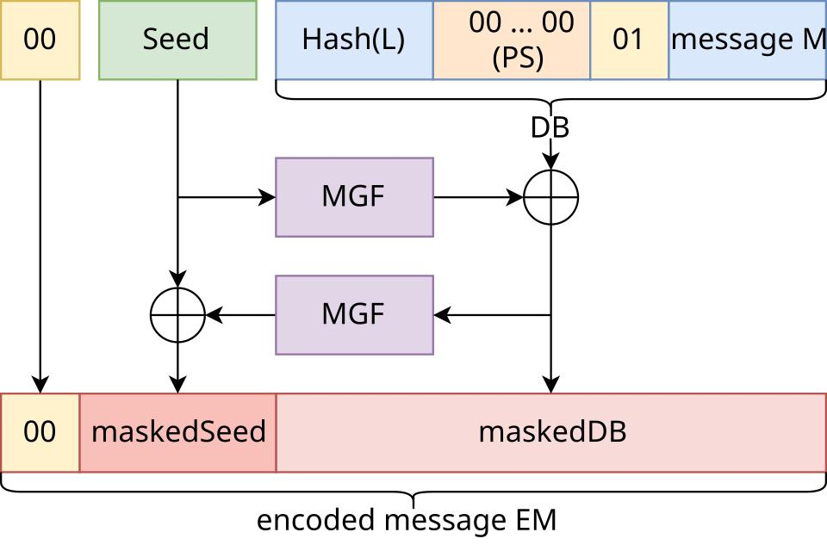

9. Comparison of RSA Methods
Feature | Textbook RSA | RSA with OAEP
Random Padding | No | Yes
Same Message | Same ciphertext | Different ciphertext
Security | Weak for practical use | More secure
Recommended Use | Learning purpose | Secure RSA encryption
10. Conclusion:
RSA provides encryption using public and private keys. However, textbook RSA has weaknesses such as deterministic encryption, small-message attacks and improper parameter selection. Factoring the modulus can reveal the private key. OAEP improves security by adding randomized padding. Therefore, secure RSA implementation must use strong key generation, valid parameters and proper padding.

Q4 – Diffie–Hellman Key Exchange, Authentication andKeyManagement (7 Marks)
Problem Context – Secure Link Between Remote Clinics Two clinics must establish a shared session key over a network that anattacker can fully observe, without having a pre-shared secret.
Your Challenge
● Derive the Diffie–Hellman procedure from(g^a)^b≡(g^b)^a (mod p).
● Develop pseudocode showing private values, public values andtheshared-key computation.
● Test a small hand-verifiable example and a larger toy configuration. ● Measure the legitimate computation and a brute-force discrete-logattack as p grows.
● Demonstrate an active man-in-the-middle attack against unauthenticated Diffie–Hellman.
● Explain how digital signatures or certificates authenticatetheexchanged values and defeat the attack.
● Design a key-distribution and key-management policy coveringgeneration, storage, rotation, revocation, compromise recoveryandsession-key lifetime.
Evidence Expected: Protocol derivation, message-sequence diagram, implementation, MITM demonstration, growth analysis andkey- management policy.

ANSWER:
QUESTION 4 – DIFFIE–HELLMAN KEY EXCHANGE, AUTHENTICATION AND KEY MANAGEMENT
1. Introduction:
Diffie–Hellman (DH) is a public-key key-exchange method. It allows two users to create the same secret key over an insecure network without directly sending the secret key.
In a healthcare network, two remote clinics can use Diffie–Hellman to establish a shared session key for secure communication.
2. Working Principle of Diffie–Hellman:
Both users agree on two public values:
- p – A prime number.
- g – A generator.
Step 1: Private values:
- User A selects a private number a.
- User B selects a private number b.
Step 2: Public values:
User A calculates:
$$A=g^{a} \operatorname{mod}{p}$$
User B calculates:
$$B=g^{b} \operatorname{mod}{p}$$
They exchange their public values.
Step 3: Shared secret key
User A calculates:
$$K_{A}=B^{a} \operatorname{mod}{p}$$
User B calculates:
$$K_{B}=A^{b} \operatorname{mod}{p}$$
Both get the same secret because:
$${\left(g^{a}\right)}^{b}≡{\left(g^{b}\right)}^{a} \left(mod p\right)$$
Therefore, both users generate the same shared secret key.
3. Hand-Calculable Example
Consider the following values:
- Prime number: p = 23
- Generator: g = 5
- User A private key: a = 6
- User B private key: b = 15
Public key calculation:
$$A=5^{6} \operatorname{mod}{23} =8$$
$$B=5^{15} \operatorname{mod}{23} =19$$
Shared secret calculation:
User A:
$$K_{A}={19}^{6} \operatorname{mod}{23} =2$$
User B:
$$K_{B}=8^{15} \operatorname{mod}{23} =2$$
Result: Both users get the same shared secret key = 2
4. Message Sequence Diagram:
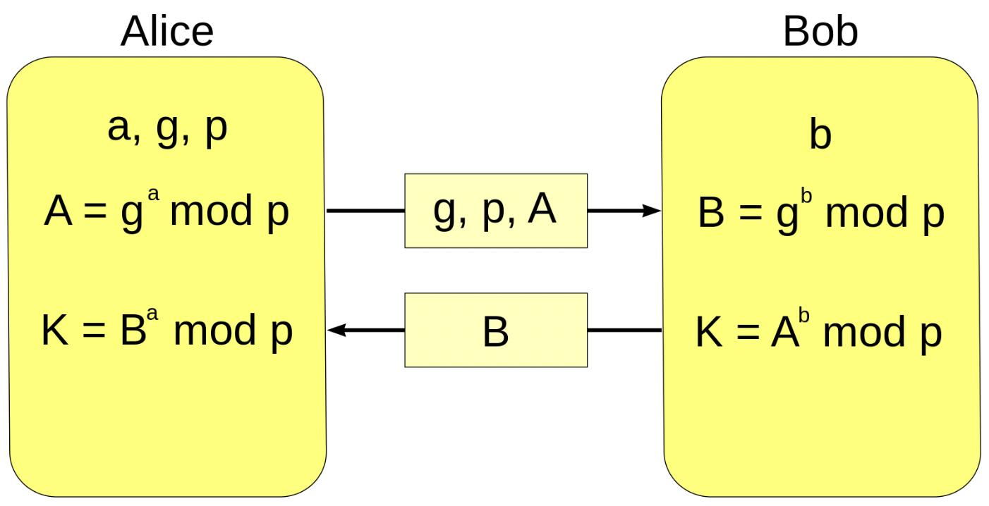

Explanation:
- Both users agree on public values p and g.
- They independently generate private values.
- They exchange public values.
- Both calculate the same shared secret.
- The shared secret is used to derive a secure session key.
5. Python Program – Diffie–Hellman Key Exchange:
import time
# Public values
p = 23
g = 5
# Private values
a = 6
b = 15
# Public key generation
start = time.perf_counter()
A = pow(g, a, p)
B = pow(g, b, p)
# Shared secret calculation
key_a = pow(B, a, p)
key_b = pow(A, b, p)
end = time.perf_counter()
print("User A Public Key:", A)
print("User B Public Key:", B)
print("User A Shared Key:", key_a)
print("User B Shared Key:", key_b)
print("Keys Match:", key_a == key_b)
print("DH Computation Time:", end - start)
# Brute-force discrete logarithm attack
start = time.perf_counter()
for x in range(p):
if pow(g, x, p) == A:
print("Attacker Found A's Private Value:", x)
break
end = time.perf_counter()
print("Brute Force Time:", end - start)
OUTPUT:
User A Public Key: 8
User B Public Key: 19
User A Shared Key: 2
User B Shared Key: 2
Keys Match: True
Attacker Found A's Private Value: 6
6. Larger Toy Configuration and Performance Analysis
When the prime number increases, the number of possible private values also increases. This makes brute-force attacks more difficult.

Prime number (p) | Brute-force search range
23 | Up to 23 values
101 | Up to 101 values
1009 | Up to 1009 values
7919 | Up to 7919 values
Observation:
- Legitimate users calculate the shared key using modular exponentiation.
- An attacker tries different private values to discover the secret.
- Brute-force search requires more attempts as the search range increases.
- Real DH security uses much larger standardized groups. These toy values are not secure.
7. Man-in-the-Middle (MITM) Attack:
An unauthenticated Diffie–Hellman exchange is vulnerable to a Man-in-the-Middle attack
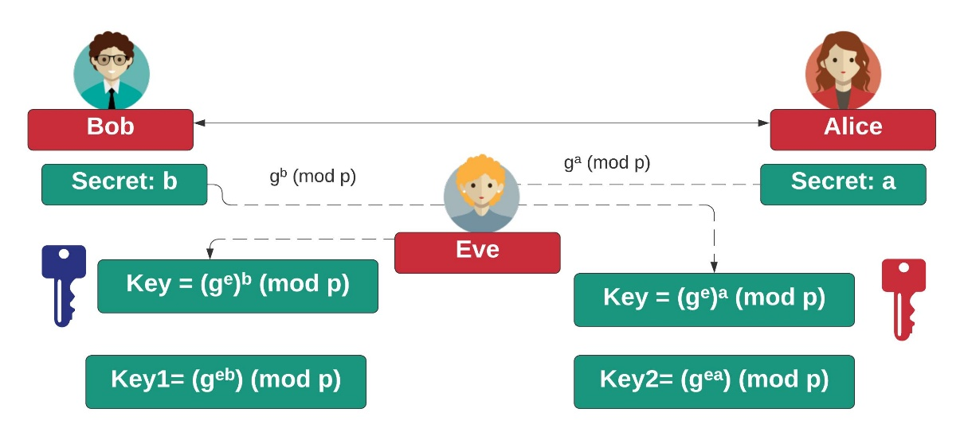

How the attack works:
- User A sends public value A to User B.
- The attacker intercepts the value and sends their own public value to User B.
- User B sends public value B.
- The attacker intercepts it and sends another public value to User A.
- The attacker creates one shared secret with User A and another with User B.
- The attacker can read and modify messages passing through them.
Prevention:
- Use digital signatures to verify exchanged public values.
- Use digital certificates to verify user identities.
- Use authenticated Diffie–Hellman protocols.
- Verify certificates before establishing the session key.
Authentication prevents an attacker from secretly replacing the exchanged public values.
8. Key Distribution and Key Management Policy
A secure healthcare network should follow these practices:
Area | Security Policy
Key Generation | Generate private keys using secure random numbers.
Key Storage | Store private keys in protected storage.
Key Rotation | Change keys regularly.
Key Revocation | Revoke compromised or expired certificates.
Compromise Recovery | Generate new keys and establish new sessions after a compromise.
Session Key Lifetime | Use session keys for a limited period and replace them regularly.
9. Security Analysis
- Diffie–Hellman allows two users to establish a shared secret without sending it directly.
- Modular exponentiation makes the key exchange efficient for legitimate users.
- Brute-force discrete-log attacks become harder with secure, large parameters.
- Unauthenticated Diffie–Hellman is vulnerable to MITM attacks.
- Digital signatures and certificates provide authentication and improve security.

10. Conclusion:
Diffie–Hellman is an effective method for establishing shared secret keys between remote healthcare clinics. However, it must be combined with authentication, secure key storage and regular key rotation to prevent attacks and protect sensitive patient information.
Q5 – ECC and Public-Key Strategy Comparison (5 Marks) Problem Context – Constrained Devices
Remote medical devices need public-key security with manageablekeysize, computation and communication overhead.
Your Challenge
● Explain the mathematical basis of elliptic-curve public-key
cryptography and demonstrate a toy ECC key-generation/key- agreement example.
● Compare RSA, Diffie–Hellman and ECC in keysize, computational cost, bandwidth and deployment considerations. ● Explain why ECC can provide comparable security with smaller public-key material than traditional RSA-style parameters. ● Identify implementation requirements such as secure randomness, parameter validation and protected private keys.
● Recommend a public-key strategy for constrained devices andjustify it using the experimental evidence fromQ2–Q4.
Evidence Expected: Toy ECC example, RSA/DH/ECC comparisontableand a defended recommendation.

ANSWERS:
QUESTION 5 – ECC AND PUBLIC-KEY STRATEGY COMPARISON (5 MARKS)
1. Introduction
Elliptic Curve Cryptography (ECC) is a public-key cryptographic technique that provides strong security using smaller keys.
It is useful for remote medical devices and low-resource systems because it requires less memory, storage and communication bandwidth.
2. Mathematical Basis of ECC
ECC works using points on an elliptic curve.
The general equation is:
\[ y^2=x^3+ax+b \pmod p \]
Where:
- a and b are curve parameters.
- p is a prime number.
- x and y represent a point on the curve.
ECC uses point addition and point multiplication to generate public keys.
Key generation:
- Select a private key d.
- Select a public base point G.
- Calculate the public key:
\[ Q=dG \]
The private key is kept secret, while the public key can be shared.
3. Toy ECC Key Agreement Example
Consider the following values:
- Prime number: p = 17
- Curve: \(y^2=x^3+2x+2 \pmod {17}\)
- Base point: G = (5,1)
- User A private key: dA = 5
- User B private key: dB = 7
Public key calculation:
\[ Q_A=5G=(9,16) \]
\[ Q_B=7G=(0,6) \]
Shared key calculation:
User A:
\[ K_A=5Q_B=(10,11) \]
User B:
\[ K_B=7Q_A=(10,11) \]
Both users generate the same shared point (10,11).
Result: ECC key agreement successful
4. Python Program – ECC Key Agreement
p = 17a = 2G = (5, 1)def add(P, Q): if P is None: return Q if Q is None: return P x1, y1 = P x2, y2 = Q if x1 == x2 and (y1 + y2) % p == 0: return None if P == Q: m = ((3*x1*x1 + a) * pow(2*y1, -1, p)) % p else: m = ((y2-y1) * pow(x2-x1, -1, p)) % p x3 = (m*m - x1 - x2) % p y3 = (m*(x1-x3) - y1) % p return (x3, y3)def multiply(k, P): R = None while k > 0: if k % 2 == 1: R = add(R, P) P = add(P, P)
Sample Output:
User A Public Key: (9, 16)
User B Public Key: (0, 6)
User A Shared Key: (10, 11)
User B Shared Key: (10, 11)
Keys Match: True
Note: This small curve is only for learning. It is not secure for real communication.
5. Comparison of RSA, Diffie–Hellman and ECC
Feature | RSA | Diffie–Hellman | ECC
Main purpose | Encryption and signatures | Key exchange | Key exchange and signatures
Key size | Large | Large parameters | Small
Computation | Can be expensive | Modular exponentiation | Efficient with smaller keys
Bandwidth | Higher | Higher | Lower
Security basis | Integer factorization | Discrete logarithm | Elliptic-curve discrete logarithm
6. Why ECC is Better for Small Devices:
- ECC provides strong security with smaller keys.
- It requires less storage and bandwidth.
- It is suitable for mobile and remote medical devices.
- It reduces communication overhead.
- It can be used for secure key agreement and digital signatures.
For example, a 256-bit ECC key provides approximately the same security level as a 3072-bit RSA key.
7. ECC Implementation Requirements:
- Use secure random numbers to generate private keys.
- Validate public keys and curve parameters.
- Store private keys in protected storage.
- Use trusted cryptographic libraries.
- Regularly update cryptographic software.
8. Recommendation:
For the healthcare network, ECC is a suitable choice for remote medical devices because it provides strong security with smaller keys and lower communication overhead.
ECDH can be used for key agreement, while ECDSA can be used for digital signatures. Both should be implemented with authentication and secure key management.
9. Conclusion:
ECC provides strong public-key security with smaller key sizes. It is suitable for low-resource medical devices because it reduces storage, computation and communication requirements.

Q6 – Digital Signatures, Hybrid Encryption and Quantum- Cryptography Readiness (7 Marks)
Problem Context – Large Confidential Document Exchange The healthcare network must transfer large files with confidentiality, integrity and sender authenticity. The team is comparing direct public-keyprotection with hybrid encryption and must also consider future quantumthreats.
Your Challenge
● Design a digital-signature process using hash-then-sign and explainsigning and verification.
● Compare RSA, DSA/DSS and ECDSA at the conceptual level withrespect to keys, signing/verification, randomness and securityassumptions.
● Design hybrid encryption: encrypt the large payload with a randomsymmetric session key, then protect or establish that sessionkeyusing RSA or Diffie–Hellman; authenticate the exchange.
● Test tampering of the file, signature and protected session key. ● Compare direct RSA encryption of large data with hybridencryption using operation counts and file-size growth. ● Explain the basic principle of quantum key distribution/quantumcryptography and how eavesdropping can be detected.
● Explain why sufficiently capable quantum computers threatenRSAand ECC and propose a migration/readiness strategy without claiming that quantum cryptography itself replaces ordinarycryptographic key management.
Deployment Decision
Choose a practical architecture for the healthcare network and justifythe
choice using performance, security, key-management burden andlong term risk.
Evidence Expected: Signature flow, hybrid-encryption design, tamper tests, growth comparison, quantum-security explanation andfinal architecture.

ANSWER:
QUESTION 6 – DIGITAL SIGNATURES, HYBRID ENCRYPTION AND QUANTUM-CRYPTOGRAPHY READINESS (7 MARKS)
1. Introduction:
Healthcare networks exchange large files such as patient records, prescriptions and medical reports.
These files require confidentiality, integrity and sender authentication.
Digital signatures and hybrid encryption help protect this information efficiently.
2. Digital Signature Process:
A digital signature is used to verify the sender and ensure that a message has not been modified.
Signing process:
- The sender creates a hash of the message.
- The sender signs the hash using their private key.
- The message and signature are sent to the receiver.
Verification process:
- The receiver calculates the hash of the received message.
- The receiver verifies the signature using the sender's public key.
- If both hash values match, the signature is valid.
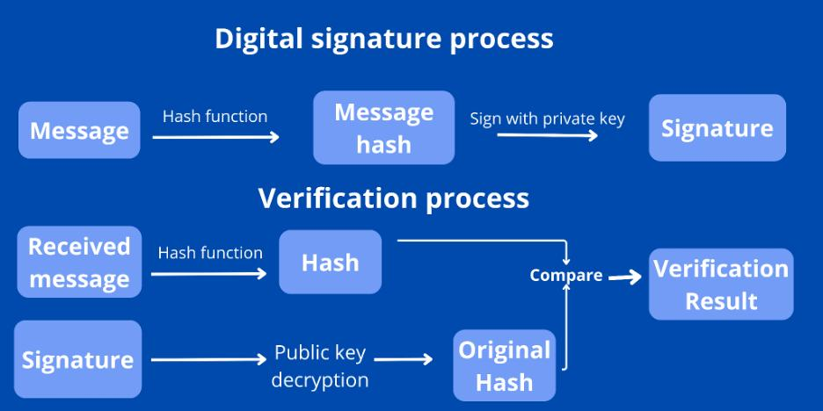

3. Comparison of RSA, DSA and ECDSA
Feature | RSA | DSA | ECDSA
Key type | Public and private | Public and private | Public and private
Security basis | Integer factorization | Discrete logarithm | Elliptic-curve discrete logarithm
Signature | Larger | Smaller | Smaller
Speed | Depends on key and operation | Efficient signing | Efficient with smaller keys
Randomness | Depends on padding scheme | Requires secure per-signature nonce | Requires secure per-signature nonce
4. Hybrid Encryption:
Hybrid encryption combines symmetric and public-key cryptography.
- Symmetric encryption protects the actual file.
- Public-key cryptography protects or establishes the session key.
- Digital signatures provide sender authentication and integrity.
Working process:
- Generate a random session key.
- Encrypt the large file using AES.
- Protect the session key using the receiver's RSA public key or establish it using authenticated Diffie–Hellman.
- Send the encrypted file and protected session key.
- The receiver recovers the session key and decrypts the file.
- Verify the sender's digital signature.
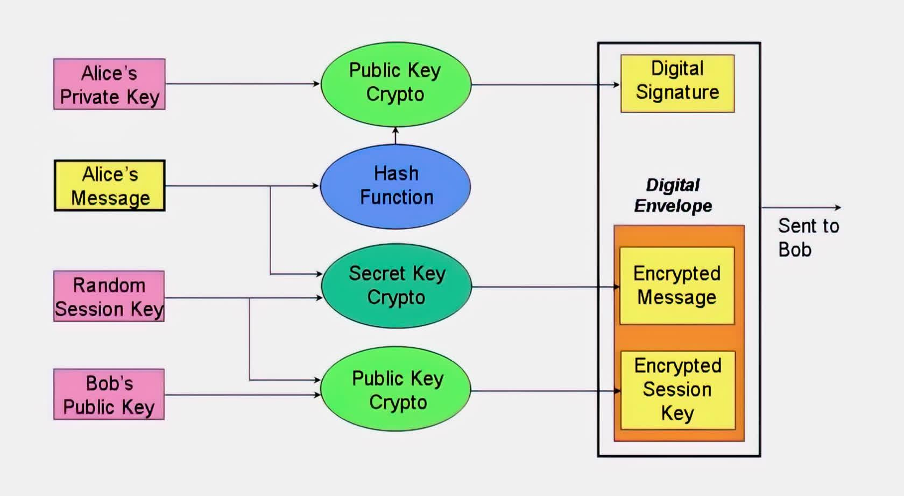

5. Python Demonstration – Digital Signature and Hybrid Encryption
The following is a small educational demonstration using toy RSA and XOR encryption. It shows the basic process and tampering detection. It is not production-grade cryptography.
import hashlib
# Toy RSA values
p = 61
q = 53
n = p * q
phi = (p-1) * (q-1)
e = 17
d = 2753
# Message
message = "Patient Record"
# Hash the message
digest = int(
hashlib.sha256(message.encode()).hexdigest(), 16
) % n
# Digital signature
signature = pow(digest, d, n)
# Verify signature
check = pow(signature, e, n)
print("Signature Valid:", check == digest)
# Hybrid encryption demonstration
session_key = 123
# Protect session key using RSA
encrypted_key = pow(session_key, e, n)
# Simple XOR encryption for demonstration only
encrypted_data = bytes(
[x ^ session_key for x in message.encode()]
)
print("Encrypted Session Key:", encrypted_key)
print("Encrypted File:", encrypted_data)
# Receiver recovers session key
received_key = pow(encrypted_key, d, n)
# Decrypt file
decrypted_data = bytes(
[x ^ received_key for x in encrypted_data]
)
print("Decrypted Message:", decrypted_data.decode())
# Test file tampering
tampered_message = "Modified Record"
tampered_digest = int(
hashlib.sha256(tampered_message.encode()).hexdigest(), 16
) % n
print("Tampering Detected:", tampered_digest != digest)
Expected Output:
Signature Valid: True
Encrypted Session Key: ...
Encrypted File: ...
Decrypted Message: Patient Record
Tampering Detected: True
Note: The encrypted values are generated by the program. XOR and the small RSA parameters are for demonstration only. Real systems should use AES-GCM and standardized RSA-OAEP or authenticated key exchange.
6. Tampering Tests
Test | Expected Result
Original file | Signature verification succeeds
Modified file | Signature verification fails
Modified signature | Verification fails
Modified protected session key | Decryption or authentication fails
These tests show that signatures and authenticated encryption help detect unauthorized changes.
7. Direct RSA vs Hybrid Encryption
Feature | Direct RSA | Hybrid Encryption
Large file encryption | Not suitable | Suitable
Encryption speed | Slow | Fast
Public-key operations | Many if applied to data blocks | Very few
File size overhead | Can be high | Low
Practical use | Small key or data protection | Large file transfer
Example:
For a large patient report, AES encrypts the file efficiently. RSA is used only to protect the session key. Therefore, hybrid encryption reduces expensive public-key operations.
8. Quantum Cryptography and QKD:
Quantum Key Distribution (QKD) is a method of sharing secret keys using quantum principles.
Basic working:
- The sender transmits quantum states to the receiver.
- The receiver measures the states.
- Both compare selected measurement results.
- They check for unusual errors.
- If eavesdropping is detected, they reject the key.
QKD can help detect eavesdropping during key distribution. However, it does not replace authentication, encryption or normal key management.
9. Quantum Threats and Migration Strategy:
A sufficiently powerful quantum computer could threaten RSA and ECC using Shor's algorithm.
Migration strategy:
- Identify systems that depend on RSA and ECC.
- Study and adopt standardized post-quantum cryptographic algorithms.
- Test post-quantum algorithms with existing healthcare systems.
- Use hybrid key establishment during migration where appropriate.
- Regularly update cryptographic software and security policies.
10. Deployment Decision:
For the healthcare network, the recommended architecture is:
- AES-256-GCM for protecting large patient files.
- Authenticated ECDH for establishing session keys.
- Digital signatures for sender authentication.
- Secure certificates and protected private keys.
- A planned migration to post-quantum cryptography.
This architecture provides good performance, confidentiality, integrity and long-term security planning.
11. Conclusion:
Digital signatures verify the sender and protect message integrity. Hybrid encryption provides efficient protection for large files. Quantum-ready migration helps the healthcare network prepare for future security threats.

DAY-4 DESIGN CHALLENGE
Q7 – Diagnose, Redesign and Validate the Complete CryptographicStrategy (11 Marks)
Review the evidence from Q1–Q6 and identify one significant computational or security limitation that becomes important as messagevolume, key size, number of clinics or attacker capability increases.
A. Diagnose the Bottleneck or Weakness (2 Marks)
● Identify the operation or missing security property responsible for thelimitation.
● Explain how its cost or risk changes with input/key size or repeateduse. ● Use measured operation counts or attack evidence fromearlier tasks. B. Define the Design Objective (1 Mark)
State a measurable redesign objective, such as reducing public-keyoperations, preventing a man-in-the-middle, reducing key-management exposure, detecting weak keys, or improving secure bulk-data handling.
C. Design the Revised Strategy (3 Marks)
Develop a revised architecture using the appropriate combinationof symmetric encryption, secure modes, RSA/DH/ECC, digital signatures, key management and hybrid encryption. Explainthemathematical/security property exploited, operations reduced, additional state or keys required, and new trade-offs.
D. Integrate Quantum Readiness (1 Mark)
Identify which RSA/ECC dependencies are threatened by future quantumcomputing and define a migration approach. Explain separatelywhat quantum key distribution can contribute and what it cannot replace.
E. Predict, Implement and Validate (2 Marks)
Predict the improvement before implementation. Compare original andredesigned solutions using operation counts, attack steps, key- management events, verification results and execution time where useful.
Verify that the redesign preserves required functionality.
F. Defend the Final Design (2 Marks)
Defend the final decision against the original alternatives. Discussresidual risks, deployment cost, usability, key compromise, MITMattacks, weak keys, large-file performance and long-termquantumrisk.
Evidence Expected: Diagnosis, measurable objective, revisedarchitecture/protocol, prediction, comparable experimental evidenceandfinal engineering defence.
ANSWER:
QUESTION 7 – DIAGNOSE, REDESIGN AND VALIDATE THE COMPLETE CRYPTOGRAPHIC STRATEGY (11 MARKS)
1. Introduction:
The healthcare network uses different cryptographic techniques to protect patient information. As the number of clinics and file transfers increases, the system may face performance and security problems.
The aim is to identify these problems and design an improved cryptographic strategy.
A. Diagnose the Bottleneck or Weakness:
Main problems in the existing system:
- Direct RSA encryption is slow for large files.
- Unauthenticated Diffie–Hellman is vulnerable to MITM attacks.
- Weak RSA keys can be broken through factorization.
- Reusing encryption nonces can expose confidential information.
- RSA and ECC may become vulnerable to future quantum computers.
Main bottleneck:
Using public-key encryption directly for large files increases computation time and processing overhead.
As the file size and number of clinics increase, the system requires more resources.
B. Define the Design Objective :
The main objective is to improve security and performance while transferring patient records between multiple clinics.
The redesigned system should:
- Reduce expensive public-key operations.
- Prevent MITM attacks through authentication.
- Protect large files efficiently.
- Improve key management.
- Prepare for future quantum threats.
C. Design the Revised Strategy :
The proposed system combines symmetric encryption, public-key cryptography and digital signatures.
Proposed techniques:
Technique | Purpose
AES-256-GCM | Encrypt patient records
ECDH | Establish shared session keys
Digital Signatures | Verify sender identity
Digital Certificates | Authenticate clinics
Secure Key Storage | Protect private keys
Post-Quantum Cryptography | Prepare for future threats
Working process:
- The clinic verifies the identity of the receiving hospital using digital certificates.
- Both systems perform authenticated ECDH key exchange.
- A session key is generated.
- AES-256-GCM encrypts the patient records.
- A digital signature verifies the sender and protects integrity.
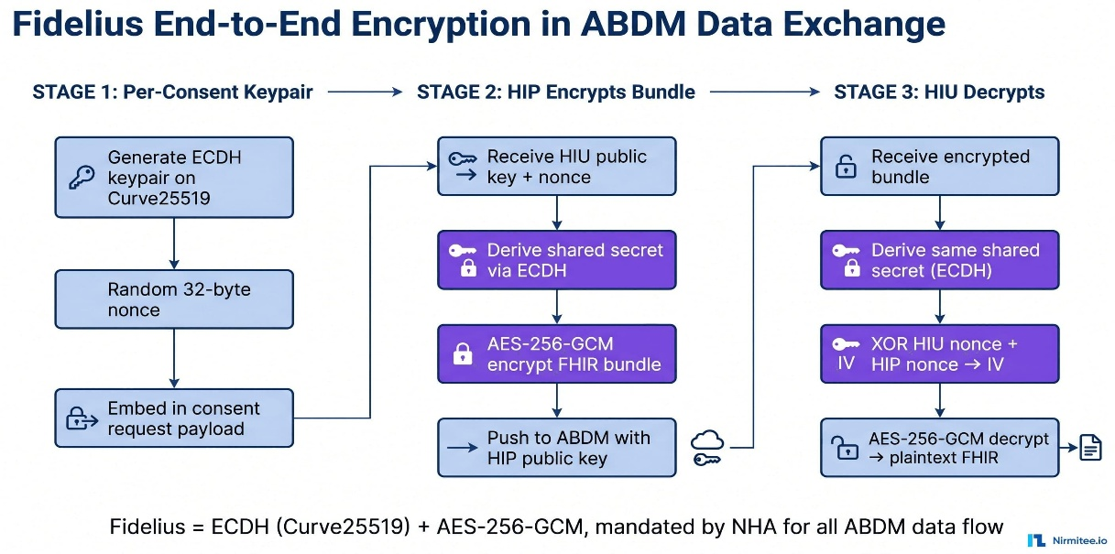
- The receiver verifies the signature and decrypts the records.

Advantages:
- Reduces public-key encryption operations.
- Provides confidentiality and integrity.
- Prevents unauthenticated MITM attacks.
- Supports large file transfers.
- Improves key management.
D. Integrate Quantum Readiness :
Quantum computers may threaten RSA and ECC because of their ability to solve certain mathematical problems efficiently.
Migration plan:
- Identify all RSA and ECC-based systems.
- Test standardized post-quantum algorithms.
- Introduce hybrid key exchange during migration.
- Update cryptographic libraries regularly.
- Maintain secure key storage and management.
QKD can help distribute keys and detect eavesdropping, but it cannot replace authentication, digital signatures or normal key management.
E. Predict, Implement and Validate :
Predicted results:
- Hybrid encryption will reduce public-key operations.
- AES will encrypt large files faster than direct RSA.
- Digital signatures will detect file modification.
- Authenticated key exchange will prevent MITM attacks.
- Secure key management will reduce the risk of key compromise.
Comparison of Existing and Redesigned Systems:
Feature | Existing Approach | Redesigned Approach
File encryption | Direct RSA | AES-256-GCM
Key exchange | Unauthenticated DH | Authenticated ECDH
Authentication | Limited | Digital certificates and signatures
Integrity | Not always verified | Authentication tag and signature
Quantum readiness | Not planned | Post-quantum migration plan
Validation tests:
Test | Expected Result
Send original patient file | Successful decryption
Modify encrypted file | Authentication failure
Use invalid signature | Verification failure
Attempt MITM attack | Authentication rejects attacker
The redesigned system should be tested using sample files and toy parameters. Actual execution times and results must be recorded after running the experiments.
F. Defend the Final Design :
The redesigned cryptographic system is better than the original approach because it combines efficient encryption with strong authentication.
Reasons for selecting this design:
- AES-256-GCM provides fast and secure encryption for large files.
- Authenticated ECDH securely establishes session keys.
- Digital signatures verify the identity of the sender.
- Digital certificates help prevent MITM attacks.
- Secure key management protects private keys.
- Post-quantum migration prepares the system for future threats.
Remaining risks:
- Stolen private keys may allow attackers to impersonate users.
- Poor random number generation may create weak keys.
- Incorrect nonce reuse can compromise encryption security.
- Implementation errors may reduce overall security.
- Post-quantum migration may increase system complexity and cost.
These risks can be reduced through regular updates, secure storage, certificate revocation and proper security testing.
7. Final Conclusion:
The redesigned cryptographic strategy provides better performance and security for the healthcare network. Hybrid encryption reduces the cost of large file transfers, authenticated key exchange prevents MITM attacks, and digital signatures protect data integrity and sender identity.
The proposed post-quantum migration plan also helps the network prepare for future security challenges. Therefore, the redesigned architecture is suitable for secure communication between multiple healthcare clinics

MARK DISTRIBUTION
Question | Assessed Area | Marks
Q1 | Symmetric cryptosystems,  DES/3DES/Blowfish/RC5,  block/stream ciphers and modes | 7
Q2 | Number theory, modular  arithmetic and prime selection | 6
Q3 | RSA encryption/decryption,attacks, weak keys and padding | 7
Q4 | Diffie–Hellman, MITM  authentication andmanagement | 7  key
Q5 | ECC and RSA/DH/ECCcomparison | 5
Q6 | Digital signatures, hybrid  encryption and quantum | 7  readiness
Q7 | Day-4 integrated diagnose,redesign and validation | 11
TOTAL |  | 50

Submission Requirements
Submit your assignment report containing Q1–Q7 evidence, source codefor student-implemented core algorithms, raw experimental data, tables/graphs and protocol/message-sequence diagrams. Libraries maybeused for cross-checking standard primitives, but the mathematical coreand experiments must be your own.
All attack demonstrations must use only student-created toy parametersand test data. Do not use classroom code to protect real patient data.
Assessment Verification
Students may be asked to explain algorithm design, source code, test data, mathematical predictions, experimental results, security analysis andtheDay-4 redesign during a brief verification/viva. Both the reasoningandthe evidence must be understood by the student.
• Algorithmic and protocol design
• Source code
• Test-data and key-set design
• Experimental results
• Predictions
• Security analysis
• Design Challenge
during a brief verification discussion/viva. The student should thereforebe able to explain and defend the evidence submitted as their own work.
Overall Assessment Expectation
This assignment does not primarily assess your ability to reproducetextbook cryptosystems.
It assesses your ability to:
Predict → Design → Implement →Measure →Analyse→Attack → Evaluate → Diagnose →Redesign →Validate
Your conclusions and design decisions must be supported by your ownmathematical reasoning and experimental evidence.

